Name: Date: .
Triangle Inequality Theorem Student Handout

Do Now: List all of the characteristics of a triangle that you can think of:

Discovering the Triangle Inequality Theorem

Strings: Pink = 2 in, Yellow = 3 in, Orange = 4 in,
Green = 5 in, Blue = 6 in, Purple = 7 in, White = 8 in

Step 1. Letter A – D: Use the three given lengths of string to form a triangle. Write if it possible or not possible to create a proper triangle using those lengths in the fourth column of the data table below.

Step 2. Letter E – G: Create your own triangles. If some length(s) are given, fill in the blank columns with a length of your choice. Just like in Step 1, test to see if the lengths form a proper triangle and record it in the fourth column of the data table below.

Length #1 | Length #2 | Length #3 | Triangle or No Triangle?
A) 2 in | 3 in | 5 in
B) 6 in | 7 in | 8 in
C) 3 in | 4 in | 5 in
D) 2 in | 4 in | 7 in
E) 4 in | 5 in
F) 2 in

G)

Step 3. Make a conjecture. What rule would apply to determining what set of lengths would successfully form a triangle? Hint: Look for patterns in your data table!

Step 4. Cut your own lengths of string to create more triangles. List three sets of lengths that will create proper triangles to validate your conjecture.

A)

B)

C)

Step 5. Final answer!
The Triangle Inequality Theorem states…

Practice Problems:

- True or false, a triangle can have side lengths 3, 12, and 15.

- True or false, a triangle can have side lengths 9, 10, and 15.

- Which set of numbers could be the lengths of the sides of a triangle?

- {6, 9, 15}
- {6, 9 ,12}
- {3, 3, 7}
- {1, 2, 3}

- Create a length to complete the missing side of this triangle.

8 ?

7

- List all of the possible lengths that could complete the missing side of this triangle.

9 ?

13

- In ΔABC, AB = 5 inches and BC = 3 inches. Which of the choices represents all possible values for AC, in inches?

- $3<AC<7$
- $3≤AC≤7$
- $2<AC<8$
- $2≤AC≤8$

- In ΔDOG, point C lies on the side of the triangle between points D and O. DG = 5, GO = 12, and DC = 3.
Which choice is a possible value for CO?

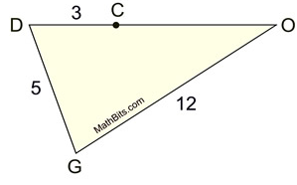
- 4
- 14
- 11
- 15

- Triangle TAB has a perimeter of 40 cm. True or false, the measures of the sides, as shown, could actually represent the measures of the sides of the triangle.
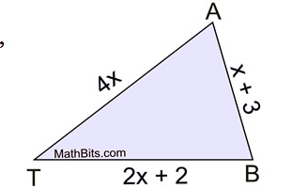

Practice Problems from: https://mathbitsnotebook.com/Geometry/SegmentsAnglesTriangles/SATIriangleInequalPractice.html

