Name: Date:
Algebra 1 Quadratic Transformations

Do Now:
Step 1: Log onto

Step 2: Select

Step 3: Type in the equation “y = x^2” in the top left hand side of the screen, here:
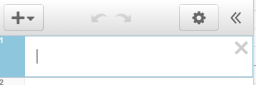

Step 4: Sketch the graph that appears on your screen on the coordinate plane below. Then, complete the table:

Parent Function:

x | y
-2
-1
0
1
2
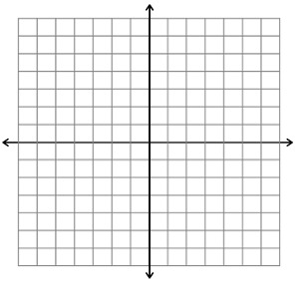

List all of the characteristics that you know about quadratic functions:

For each transformation…
Step 1: Type in the given function in the box underneath the parent function, (shown below). Do not delete the parent function! For each transformation, you will type over the previous one in the second box, so you will have two functions on your screen at all times: the parent function & transformation. The parent function will be in red; the transformation will be in blue.
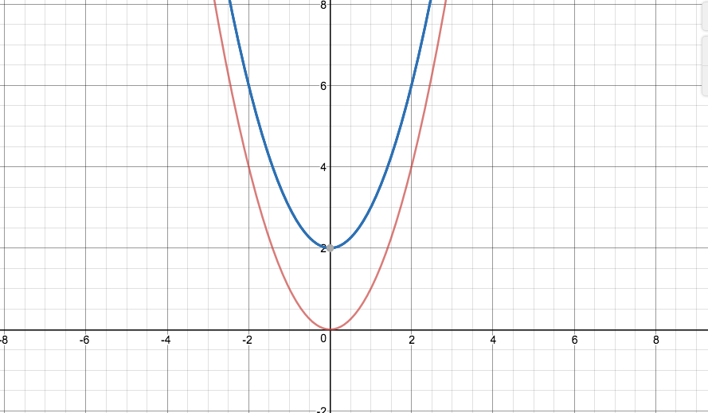
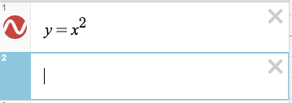

Step 2: Sketch the new graph that appears on your screen on the coordinate plane below.

Step 3: Complete the coordinate table. (Hint: Instead of clicking on each point to fill out the table, select and then 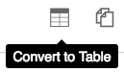and a table from -2 to 2 will appear!)

Step 4: Describe in what way the graph has changed from the parent function.

A) “y = x^2 + 5”:
x | y
-2
-1
0
1
2
Describe the transformation:

B) “y = x^2 – 3”:
x | y
-2
-1
0
1
2
Describe the transformation:

C) “y = (x + 5)^2”
x | y
-2
-1
0
1
2
Describe the transformation:

D) “y = (x – 3)^2”
Describe the transformation:

x | y
-2
-1
0
1
2

E) “y = 2x^2”
Describe the transformation:

x | y
-2
-1
0
1
2

F) “y = 1/4x^2”
Describe the transformation:
x | y
-2
-1
0
1
2

G) “ y = –x^2”
Describe the transformation:

x | y
-2
-1
0
1
2

Using Sliders:
Step 1: Type in the function, “y = a(x + b)^2 + c”
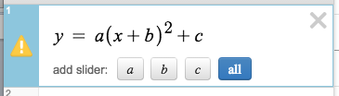
Step 2: Select “all” to add sliders for each variable, a, b, and c:
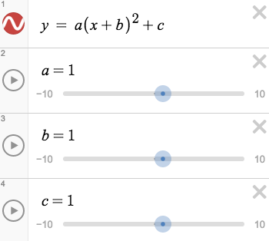
This will appear on your screen:

Step 3: Explore! Click and drag the sliders left and right to substitute different quantities for each of the variables and note how they affect the graph.

- Without using a calculator, sketch the following function: –x²+3

- Describe the ways in which the following function has been transformed from the parent function: 5(x – 2)² + 3

- Write a function to match the following graph:

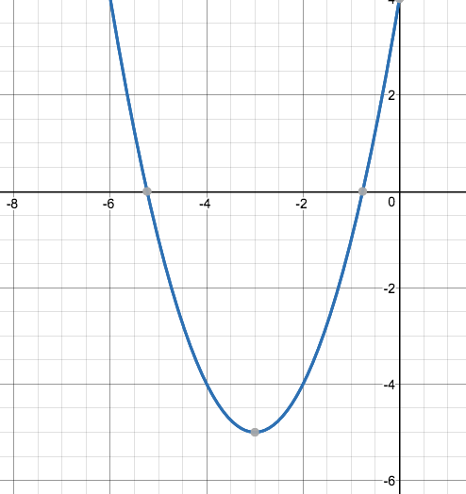

x | y
-2 | 11
-1 | 8
0 | 7
1 | 8
2 | 11
- Write a quadratic function that could match this table:

- Write an equation of the quadratic that has been reflected over the x-axis, moved downward 6 units and to the left 5 spaces.

Desmos Activity: “Match My Parabola”

Step 1: Go to

Step 2: Type in the class code: and select

Step 3: Select “Sign in with Desmos” and create an account by entering your email address and a password. Then hit, “Create Account.”

Step 4: Enter your first & last name. Once again, select, “Create Account.”

Step 5: Your name should be entered for the activity… Select

Step 6: For each of the challenges, plot a parabola through the given points. Good luck!

